Screenshots:

Trial 1:

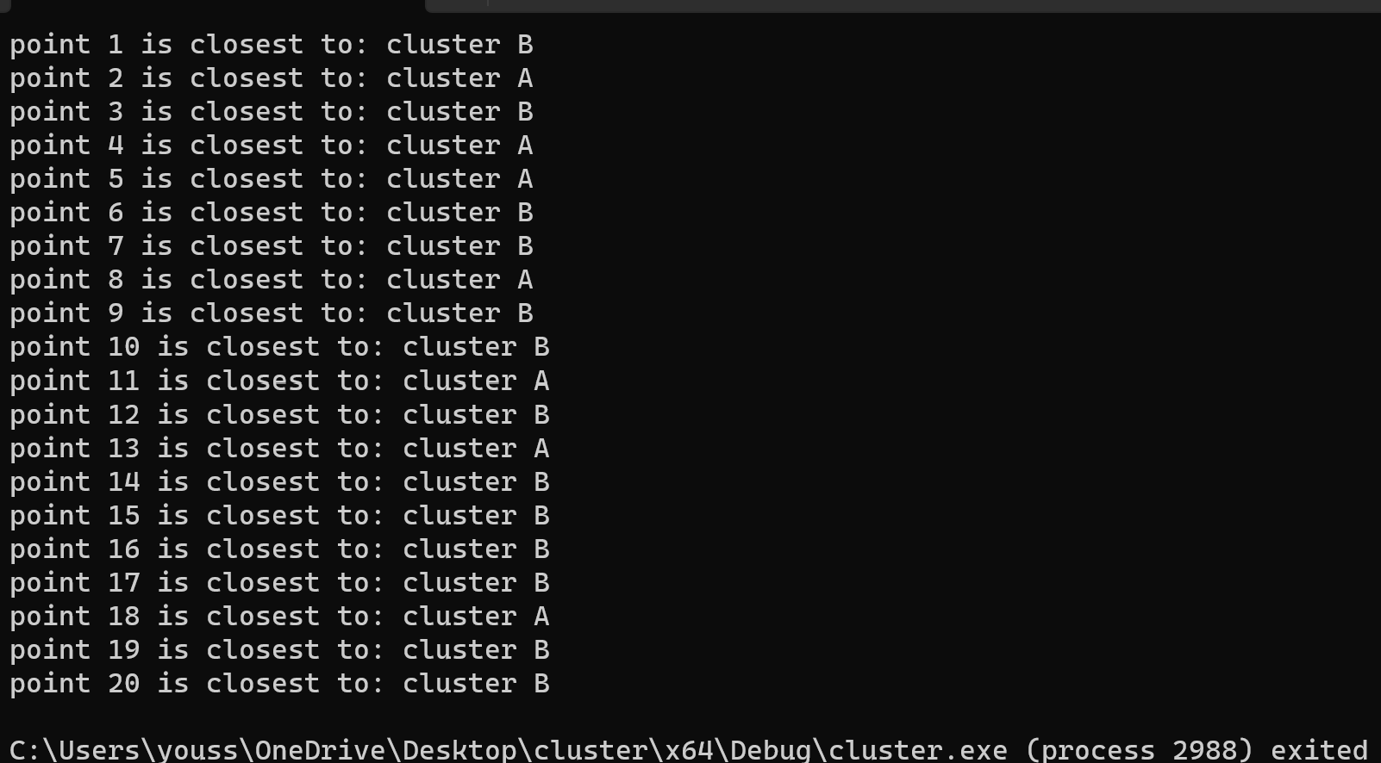

2:

3:

Comments :

I could use this :

\*(p+i).getx(); or \*(p+i).gety();

For some reason I don’t know it didn’t work so instead I used the normal index

P[i].getx()

P is a pointer to object of class point